**MODULE-1(SDLC)**

**1.What is software? What is software engineering?**

**Software :** software is a collection of computers program and related data that provide the instruction for telling a computer what to do and how to do it .software is a set of instruction , data, or programs used to operate a computer and execute specific tasks. Software is responsible for directing all computer-related devices and instructing them regarding what an how task is to be performed.

**Software engineering:** Software engineering is defined as a process of analyzing user requirements and then designing, building, and testing software application which will satisfy those requirements.

**2. Explain types of software?**

**1)System software**: system software provide the basic function for computer usage and helps run the computer hardware and system. the system software is a type of computer software that is designed For running the computer hardware parts and the application programs.it is the platform to the computer system where other computer program can execute. The operating system is the type of system software.

**2)programming software:** programming is the process of designing ,writing, testing, debugging, and maintaining the source code of computer programs. this source code written in a programming language. The purpose of programming is to create a program that exhibits a certain desired behavior.

**3)Application software:** this is the most common type of computer software, and can be defined as end-user programs that help you perform task or achieve desired outcome.

Application software there are three categories:

1.web app: apps that run on a web browser ( mozilla, google chrome etc)

2.mobiles app: application that’s runs on mobile platforms. Ex Instagram app.

3.system app:application that runs stand alone in a desktop or laptop computer. Ex Microsoft word ,web browser.

**3 .What is SDLC? Explain each phase of SDLC**

SDLC or software development life cycle is a methodology with well defined stages that enables developers to create high quality software. SDLC employs iterative mechanisms

to minimise potential errors and speed up development process. understanding SDLC,

its characteristics and benefits can useful for developers.

**1.planning** : in the planning phase ,project leaders evaluate the terms of the project. This includes calculating labor and material costs, creating a timetable with target goals, and creating a projects teams and leadership structure.

**2.implementation**: construct a solution in software.  
**3.testing** : testing is carried out of to verify the entire system. the aim of taster is to find out

the gaps and defects within the system and also to check whether the system is running according to the requirements of the customer/client.

**4.documentation**: Srs document is used for implementing system.

**5.deployment** : after successful testing ,the product is delivered/deployed to the client, and

Even clients are trained on hoe to use product.

**6.maintenance:** once the product has been delivered to the client the task of maintenance starts as when the client will come up with an error the issue should be fixed from time to time.

**4.What is DFD? Create a DFD diagram on Flipkart.**

A data flow diagram (DFD) is a traditional visual representation of the information flows within a system. A neat and clear DFD can depict the right amount of the system requirement graphically.

DFD diagram:

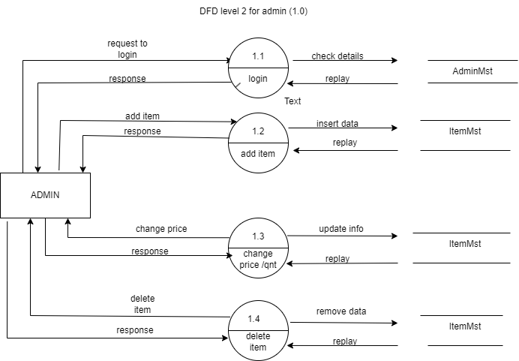

**5.What is Flow chart? Create a flowchart to make addition of two numbers**

**Flow chart**: a flow chart is a type of diagram that represent a workflow or process. A flowchart can also be defined as a diagrammatic representation of an algorithm, a step by

Step approach to solving task. Flowchart are analyzing ,designing, documenting or managing a process or programs in various fields.

Three types of flow chart:

1)linear

2)branching

3)looping

**Diagram:**

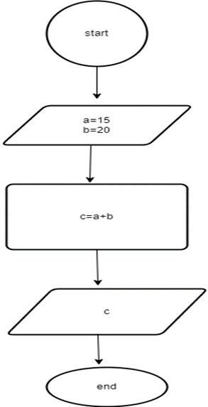

**6.What is Use case Diagram? Create a use-case on bill payment on paytm.**

A use case diagram is graphical depiction of a user possible interactions with a system .a use case diagram shows various use cases and different type of users the system has and will often be accompanied by other types of diagram as well. The use cases are represented by either circles or ellipse. The actor are often shown as stick figures.

Diagram:

